I. Team Name: Data Dawgs Plus

Stephanie Velez

Jesse Eldell

Joo Young Kang

Cheryl Maafoh

Andy Liu

II. Description of Problem and Data Model

A local Athens car rental company would like the Data Dawgs Plus team to build them a data model that tracks information about their vehicle rental service. The rental company is a startup in which customers use an app to request a vehicle for temporary use. After picking the vehicle up from a location and usage, the customer can then drop the car off at one of many authorized locations. The rental company would like to track information on the vehicle reservations and the customers who utilize the service. They would like information on the vehicle locations (pick up and drop off), fueling options, insurance, duration of the rental (request and return dates), and the agent who approved the reservation. Reservations can only have one of each of these factors, but each of these factors and pertain to a variety of reservations. Note: There is no need to track isolated information on the date.

In terms of the users making the reservations, the rental company would like to track the customers’ first and last names, residential address, email, and phone number. Additionally, the company must be aware of the customers’ date of birth and license number. It is the responsibility of the agents to authenticate this customer information. An agent can be assigned to multiple customers, but a customer can only have one assigned agent. Because the startup is still growing, the agents are outsourced and work remotely. Along with their names, the company must have the agents’ agency name, address, and phone number. After approval, the reservation will produce an electronic invoice containing the rental price plus services taxes and fees. Information on the vehicles is crucial, as it is the foundation of the service. The company would like to track the vehicle make, model, year, mileage, and color. They would also like to track the type of vehicle (ie. sedan, SUV, coupe, etc.). Additionally, the type of fuel for the vehicle is necessary to be known.

In order to encourage more users to try the app, the rental company uses monthly promotions as a marketing tactic. The company would like to track the name of the promotion, the discount amount, and a brief description. A reservation price can be lowered by multiple promotions.

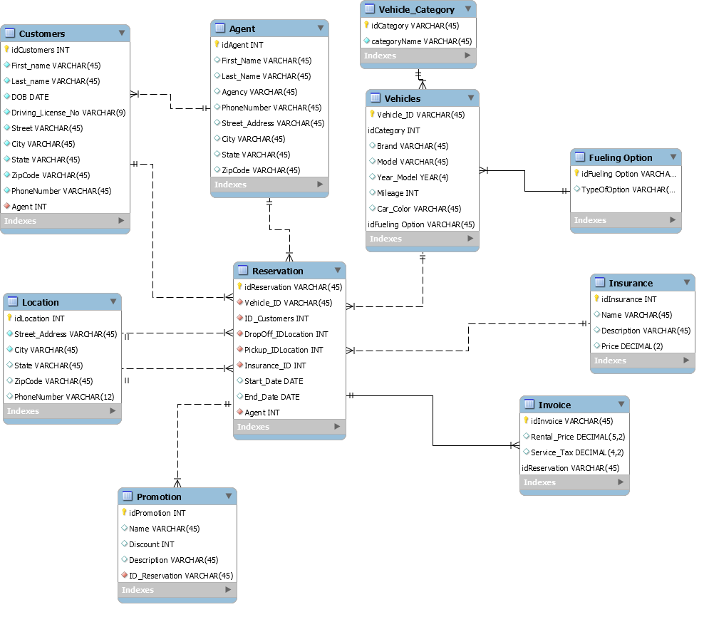III. Data Model

IV. Data Dictionary

Table: Agent

|  |  |  |  |  |  |
| --- | --- | --- | --- | --- | --- |
| Column Name | Description | Data Type | Size | Format | Key? |
| idAgent | Unique number assigned to an agent | Integer |  |  | PK |
| First_Name | First name of the agent | Varchar | 45 |  |  |
| Last_Name | Last name of the agent | Varchar | 45 |  |  |
| Agency | The name of the agency the agent belongs to | Varchar | 45 |  |  |
| PhoneNumber | The phone number of the agent | Varchar | 45 | 999-999-9999 |  |
| Street_Address | The number and name of the street where the agent is located | Varchar | 45 |  |  |
| City | The city where the agent is located | Varchar | 45 |  |  |
| State | The state where the agent is located | Varchar | 45 |  |  |
| ZipCode | The zip code of where the agent is located | Varchar | 45 | 99999 |  |

Table: Customers

|  |  |  |  |  |  |
| --- | --- | --- | --- | --- | --- |
| Column Name | Description | Data Type | Size | Format | Key? |
| idCustomers | Unique number assigned to a customer | Integer |  |  | PK |
| First_name | First name of the customer | Varchar | 45 |  |  |
| Last_name | Last name of the customer | Varchar | 45 |  |  |
| DOB | The birthday of the customer | Date |  | YYYY-MM-DD |  |
| Driving_License_No | The driving license number belonging to the customer | Varchar | 45 | 999999999 |  |
| Street | The number and name of the street where the customer is located | Varchar | 45 |  |  |
| City | The city where the customer is located | Varchar | 45 |  |  |
| State | The state where the customer is located | Varchar | 45 |  |  |
| ZipCode | The zip code of where the customer is located | Varchar | 45 | 99999 |  |
| PhoneNumber | The phone number belonging to the customer | Varchar | 45 | 999-999-9999 |  |
| Agent_Number | The id of the agent working with the customer | Integer |  |  | FK |

|  |  |  |  |  |  |
| --- | --- | --- | --- | --- | --- |
| Column Name | Description | Data Type | Size | Format | Key? |
| idFuelingOption | Id of the fueling option | Varchar | 45 |  | PK |
| TypeOfOption | Different types of fuel | Varchar | 45 |  |  |

Table: Fueling Option

Table: Insurance

|  |  |  |  |  |  |
| --- | --- | --- | --- | --- | --- |
| Column Name | Description | Data Type | Size | Format | Key? |
| idInsurance | Unique number assigned to an insurance company | Integer |  |  | PK |
| Name | The name of the insurance company | Varchar | 45 |  |  |
| Description | The description of the insurance company (describes what coverage they offer) | Varchar | 45 |  |  |
| Price | The price of having the insurance company | Decimal | 2 | $99.99 |  |

Table: Invoice

|  |  |  |  |  |  |
| --- | --- | --- | --- | --- | --- |
| Column Name | Description | Data Type | Size | Format | Key? |
| idInvoice | Unique number assigned to an invoice | Varchar | 45 |  | PK |
| Rental_Price | The rental price that was paid to rent the vehicle | Decimal | 2 | $99.99 |  |
| Service Tax | The service tax paid for the rental | Decimal | 2 | $99.99 |  |
| idReservation | The unique number of the reservation on the invoice | Varchar | 45 |  | FK |

Table: Location

|  |  |  |  |  |  |
| --- | --- | --- | --- | --- | --- |
| Column Name | Description | Data Type | Size | Format | Key? |
| idLocation | Unique number assigned to the location where you drop off/pick up the rental car | Integer |  |  | PK |
| Street_Address | The number and street of where the vehicle will be dropped off and picked up | Varchar | 45 |  |  |
| City | The city where the vehicle will be dropped off and picked up | Varchar | 45 |  |  |
| State | The state where the vehicle will be dropped off and picked up | Varchar | 45 |  |  |
| ZipCode | The zip code of the location where the vehicle will be dropped off/picked up | Varchar | 45 |  |  |
| PhoneNumber | The phone number of the location where the vehicle will be dropped off/picked up | Varchar | 12 | 999-999-9999 |  |

Table: Promotions

|  |  |  |  |  |  |
| --- | --- | --- | --- | --- | --- |
| Column Name | Description | Data Type | Size | Format | Key? |
| idPromotion | Unique number assigned to a promotion | Integer |  |  | PK |
| Name | The name of the promotion | Varchar | 45 |  |  |
| Discount | The discount offered in the promotion | Integer |  | 99 |  |
| Description | The description of the promotion | Varchar | 45 |  |  |
| idReservation | Unique ID of the reservation where the discount was applied | Varchar | 45 |  |  |

Table: Reservation

|  |  |  |  |  |  |
| --- | --- | --- | --- | --- | --- |
| Column Name | Description | Data Type | Size | Format | Key? |
| idReservation | Unique number assigned to a reservation | Varchar | 45 |  | PK |
| Vehicle_ID | Unique id assigned to the vehicle on the reservation | Varchar | 45 |  | FK |
| ID_Customers | Unique number assigned to the customer on the reservation | Integer |  |  | FK |
| DropOff_IDLocation | The unique number of the drop off location for the vehicle | Integer |  |  | FK |
| Pickup_IDLocation | The unique number of the pick up location for the vehicle | Integer |  |  | FK |
| Insurance_ID | The unique number assigned to the insurance company on the reservation | Integer |  |  | FK |
| Start_Date | The start date of the reservation | Date |  | YYYY-MM-DD |  |
| End_Date | The end date of the reservation | Date |  | YYYY-MM-DD |  |
| Agent | Unique number assigned to the agent on the reservation | Integer |  |  | FK |

Table: Vehicle_Category

|  |  |  |  |  |  |
| --- | --- | --- | --- | --- | --- |
| Column Name | Description | Data Type | Size | Format | Key? |
| idCategory | The unique number assigned to a vehicle category | Varchar | 45 |  | PK |
| categoryName | The name of the vehicle category | Varchar | 45 |  |  |

Table: Vehicles

|  |  |  |  |  |  |
| --- | --- | --- | --- | --- | --- |
| Column Name | Description | Data Type | Size | Format | Key? |
| Vehicle_ID | The unique number assigned to a vehicle | Varchar | 45 |  | PK |
| idCategory | The unique number assigned to the vehicle category the vehicle belongs to | Integer |  |  | FK |
| Brand | The brand of the vehicle | Varchar | 45 |  |  |
| Model | The model of the vehicle | Varchar | 45 |  |  |
| Year_Model | The year of the model of the vehicle | Year | 4 | YYYY |  |
| Mileage | The mileage of the vehicle | Integer |  |  |  |
| Car_Color | The color of the vehicle | Varchar | 45 |  |  |
| idFuelingOption | The unique number assigned to the type of fuel the vehicle uses | Varchar | 45 |  | FK |

V. Queries

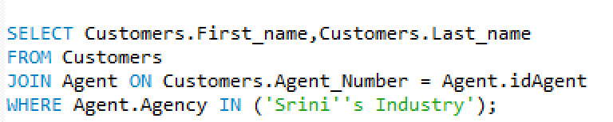

1.

1. Find the Customer first and last name whose agent works at Srini's Industry
   * 1. Agents within Srini Industry can organize their work schedules accordingly if they know which agent is working with a specific customer.
     2. 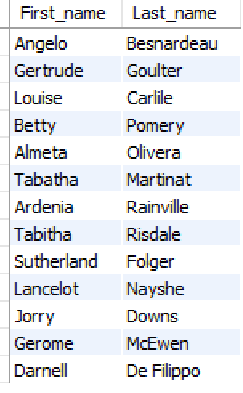

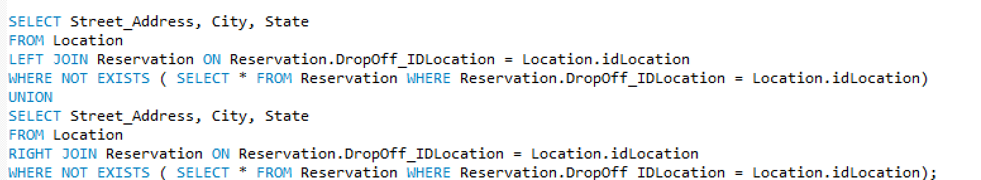

2.

1. Find the Address, City, and State of Locations that don't have a reservation
   * + 1. These locations can help the car rental company sort out places that don’t have a pickup or drop off location, so when new customers need a pickup, dropoff location, these locations can fill the vacancy.
       2. 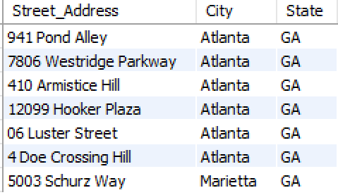

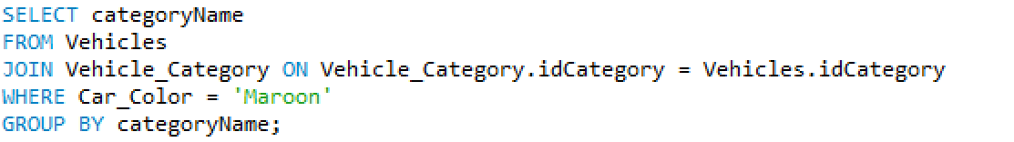3.

a. Find the names of different categories of Vehicles that are the color 'Maroon'

i. If a customer’s favorite color is Maroon, they can find the type of vehicles with that color.

ii. 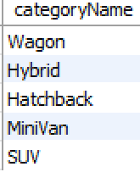

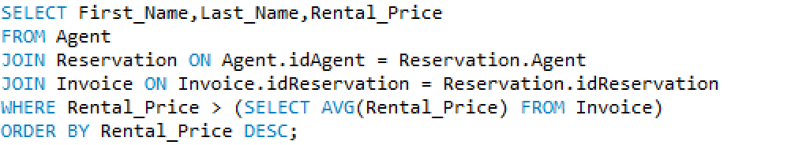4.

a. Report the Name and Rental Price of Agents that have an invoice greater than the average rental price of invoices, sorted by rental prices

i. The company can find out which agents are dealing with a customer that have a high-priced invoice which will generate high profit

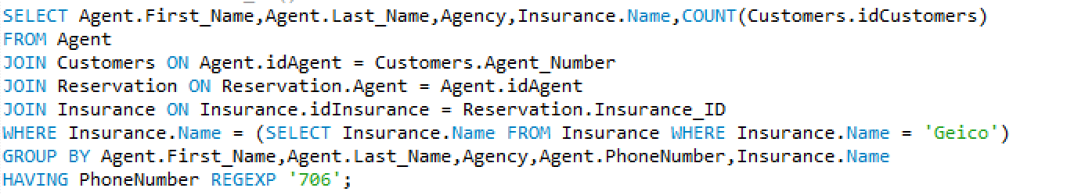 ii. 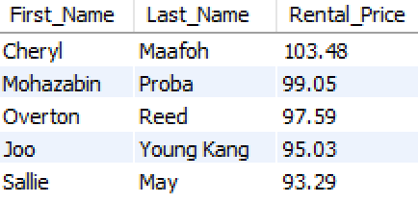

5.

1. Report the Name, Agency, and the number of Customers that an Agent has that deal with a 'Geico' Insurance Account, with the exception that their phone number has a 706 area code
2. If a customer is local around a place with a 706 area code and prefer Geico insurance, they can find the agent to call to set up the car reservation.

 ii.

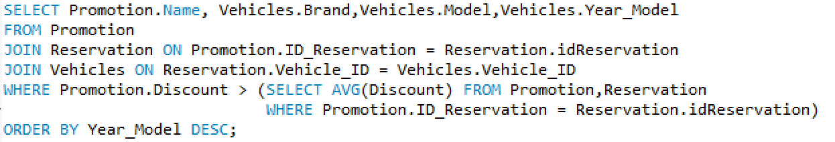6.

* 1. Display the Vehicle Brand, model, year it was modeled associated with the name of a promotional deal that is going on with it, as long as the discount is greater than the average of all discounts associated with that promotion
     1. Customers will know which vehicles have the best deals and the promotion associated with it.
     2. 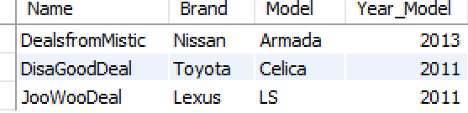

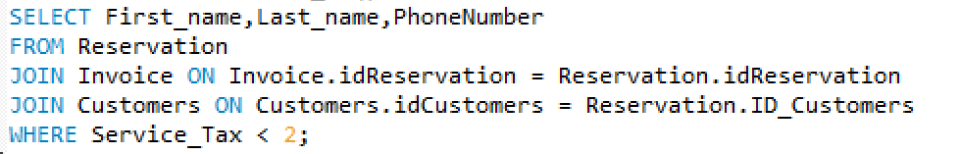7.

a. Display the Name and Phone Number of Customers who have to pay a service Tax less than $2 on the rental purchase

i. Agents can anticipate the customers that will give them a low amount of money for service tax

ii. 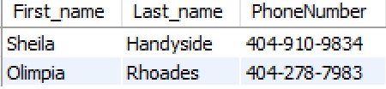

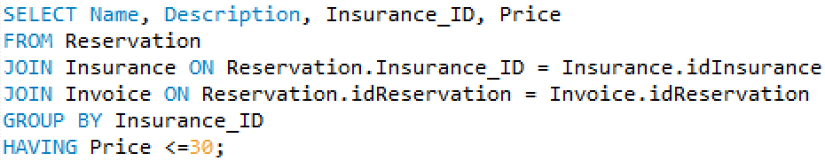8.

1. Find the names, IDs, Price, and coverage descriptions of insurance companies where the price is less than 30
2. 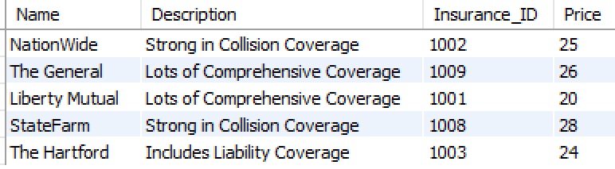Customers can see which insurance plans fall within a $30 budget.

ii.

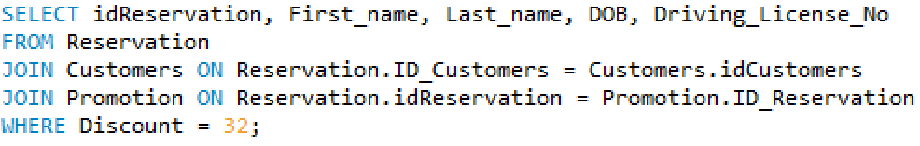

9.

a. Identify the name of the customer who had the "AndyDeal" promotion

* + 1. The company can see which customer took advantage of the AndyDeal to see if its a good promotion and if they should continue to promote it



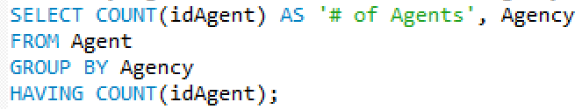10.

1. Display the number of agents in each insurance agency
   * 1. The company can know how many agents are in each of the agency departments to assess the working resources accordingly
     2. 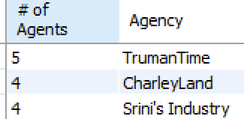

VI. Query Matrix

|  |  |  |  |  |  |  |  |  |  |  |
| --- | --- | --- | --- | --- | --- | --- | --- | --- | --- | --- |
|  | Query 1 | Query 2 | Query 3 | Query 4 | Query 5 | Query 6 | Query 7 | Query 8 | Query 9 | Query 10 |
| Multiple Table Join | x | x | x | x | x | x | x | x | x |  |
| SubQuery |  |  |  | x |  |  |  |  |  |  |
| Correlated SubQuery |  | x |  |  | x | x |  |  |  |  |
| GROUP BY |  |  | x |  |  |  |  |  |  |  |
| GROUP BY with HAVING |  |  |  |  | x |  |  | x |  | x |
| ORDER BY |  |  |  | x |  | x |  |  |  |  |
| IN or NOT IN | x |  |  |  |  |  |  |  |  |  |
| A Built-In Function (e.g., AVG) or A Calculated Field |  |  |  | x |  |  |  |  |  | x |
| REGEXP |  |  |  |  | x |  |  |  |  |  |
| NOT EXISTS |  | x |  |  |  |  |  |  |  |  |

VII. Name of database on MySQL server: DataDawgsPlus